Baby Bear Study EEG Processing Guidebook

This guide should have everything you need to process your EEG data. If you run into issues, please email me and do not change the code (other than in places you are instructed to). Email me at Kaitlyn_campbell@baylor.edu

Welcome to EEG Processing! My goal is to write this in a way that is it useful for all people in the various labs regardless of prior knowledge.
Here are some basic pieces of information for our process:
- We will be doing a two-part processing pipeline (coined preprocessing and processing).
- We will be using EEGLab and HAPPILEE (v4) within MATLAB to take our data from raw files to processed power values.

What you need to do this:
- Computer- desktop or laptop is fine, the bigger the memory the better (32GB is ideal in my opinion). It should work on lower memory computers but will be slower. Mac or PC is fine.
- MATLAB installed—go to mathworks.com and make an account then you can download it. Mathworks also has a lot of online trainings for MATLAB which can be helpful in general.
- Do NOT download EEGLAB. If you already have it on that computer, delete it.
- HAPPE downloaded and set it up.
- Files from the BabyBearStudy github, where you got this guide

Downloading & Setting up HAPPE/EEGLAB
  - Go to https://github.com/PINE-Lab/HAPPE
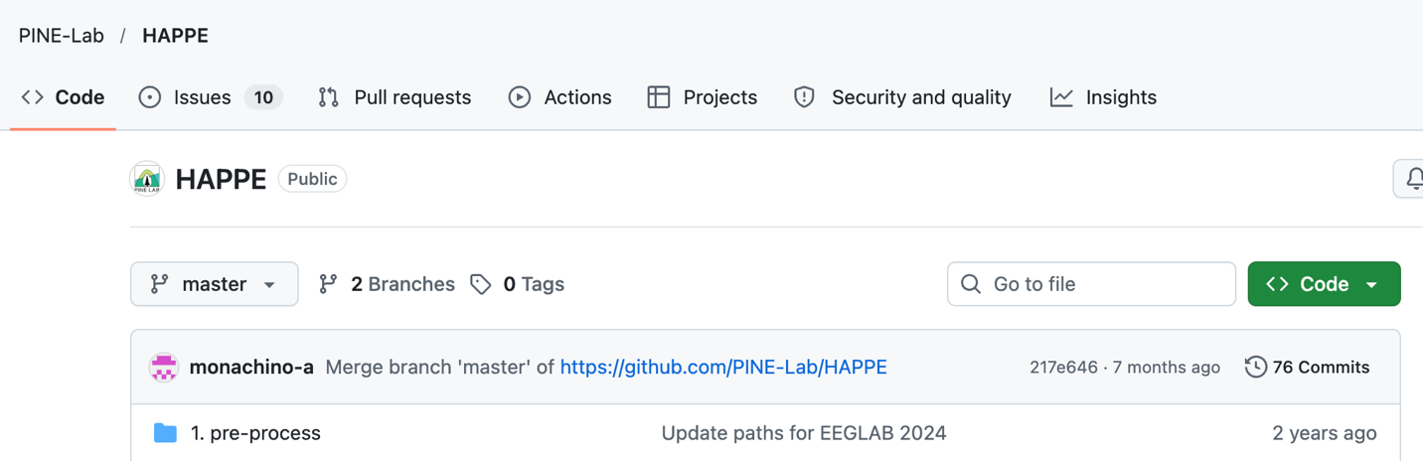
  - Click the green Code button
  - Click Download ZIP
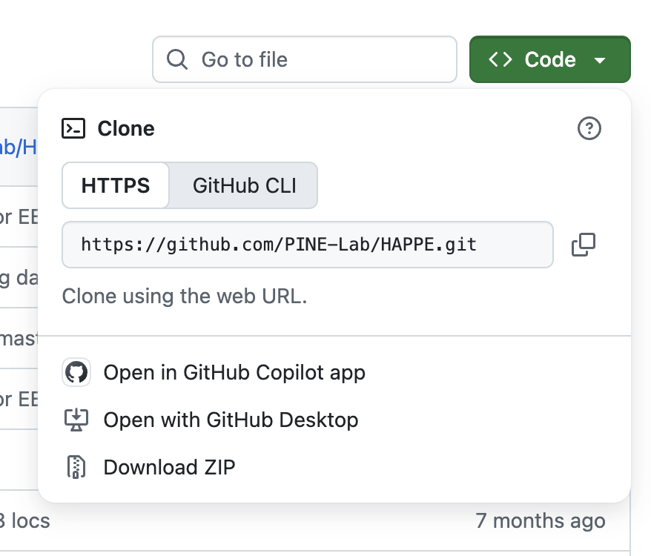
  - Let it download then unzip the folder and put it someone on your computer that makes sense. I usually put it on the desktop since I use it for multiple projects.
  - Open the folder- you’ll have a bunch of folders, but right now you need to open the HAPPE User Guide
  - Read the guide and follow ALL set up instructions (set up instructions end on page 14). Note- I did not have to do the quarantine process on my macbook.
  - Additionally, you need to download an EEGLAB extension called snapmaster.
    - Open EEGLAB
    - Click File
    - Click Manage EEGLAB Extensions, a window will open
      - If the window doesn’t open and you get an error instead. You will have to manually download the extension from github.
    - Search for snapmaster, download it.

- Other files you will need are- (we’ll talk about these later in the guide)
  - Preprocessing matlab script
  - HAPPE parameters
  - generatePower parameters

I would recommend someone with coding experience, preferably a doctoral student, to do this set up.

Setting up your raw data

You need all your EEG .sma and .cnd event files available on your computer.
File organization is to be as follows. Each rectangle below represents a file folder. Basically, each participant gets their own folder within the EEG Data folder and all their raw EEG data (from all sessions) goes in their specific Raw folder. The Processed folder will be empty initially. Also create a Ready folder, which we will eventually run HAPPILEE out of. I included an example picture below. Also put all your .cnd files in the Event Files folder.
EEG Data
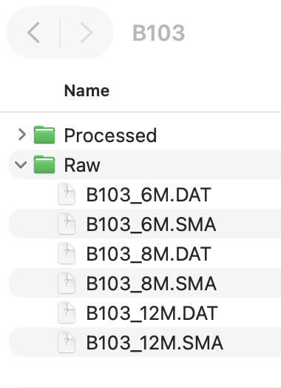
B1

Raw
Processed

B2

Raw
Processed

Event Files
Ready

This set up usually takes a bit of time and could be anyone’s job on the research team.

Event File Set Up
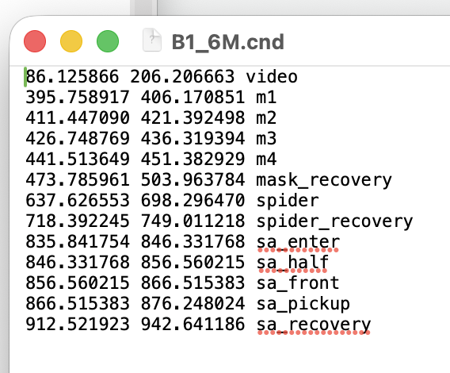
The .cnd files should be formatted as [start time] [end time] task.
Here’s an example:

Within the preprocessing we will be reformatting this into a text file, but for now, the .cnd needs to look like this. To open a .cnd file on your computer, you can right click and open the file with TextEdit (or equivalent).

Relative Gains
As we will be using the .sma EEG files, we need to tell EEGLAB what our relative gains are.
How to figure out the relative gains-
- Open your .cal file
- Look at the number in the column to the left of where the electrodes are listed
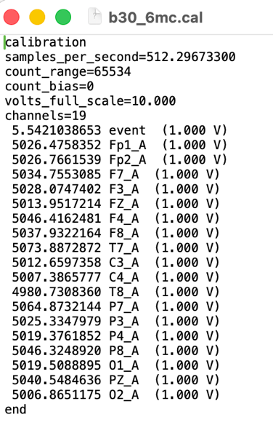
- Find the nearest whole number
  - Our gain here is about 5000
- Do this formula: 1e6/gain
  - For this example, the relative gain would be
1e6/5000 = 200
Before starting to preprocess any data, we need to make sure our relative gains and channel locations are correct.
- Open MATLAB
- Type eeglab in the command window
- When the blue GUI pops up, click File > Import data > Using EEGLAB functions and plugins > Choose Snapmaster .SMA file
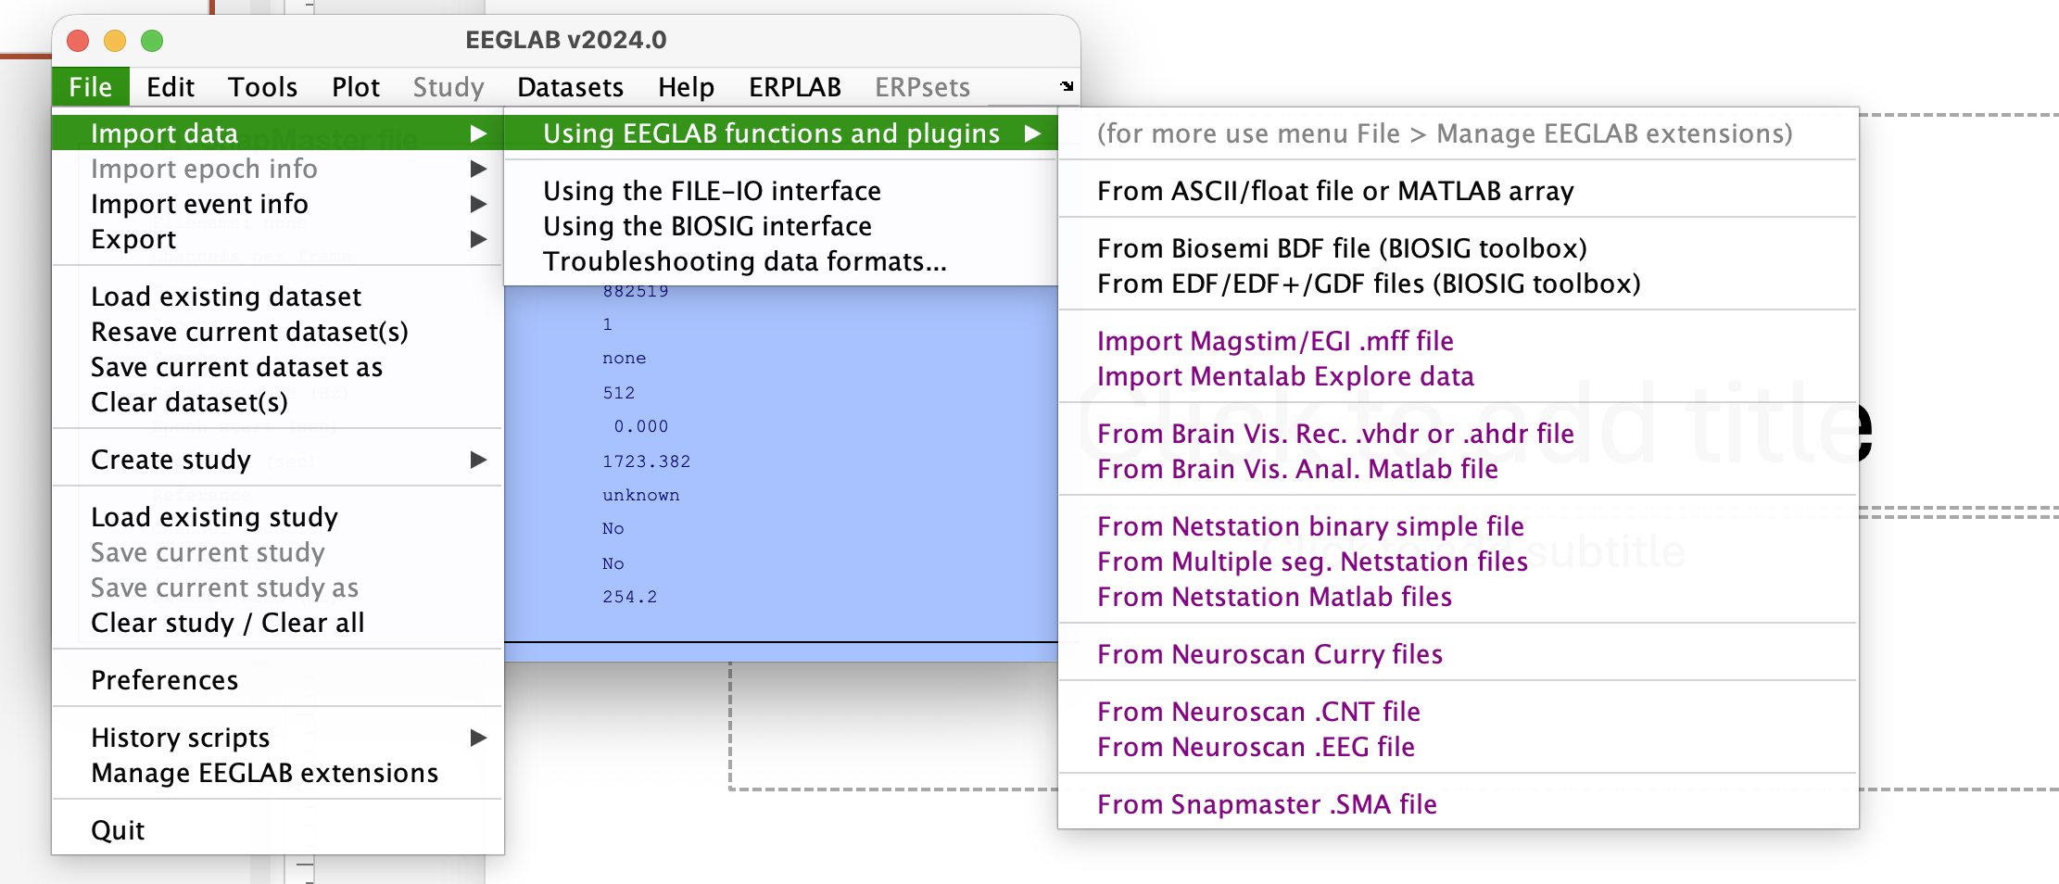
(If you don’t see the Snapmaster option, you still need to download that plugin)
- Upload one example .sma file, enter the relative gains you calculated prior
- The command window will have some new information, and the blue GUI should come back up with information about your file
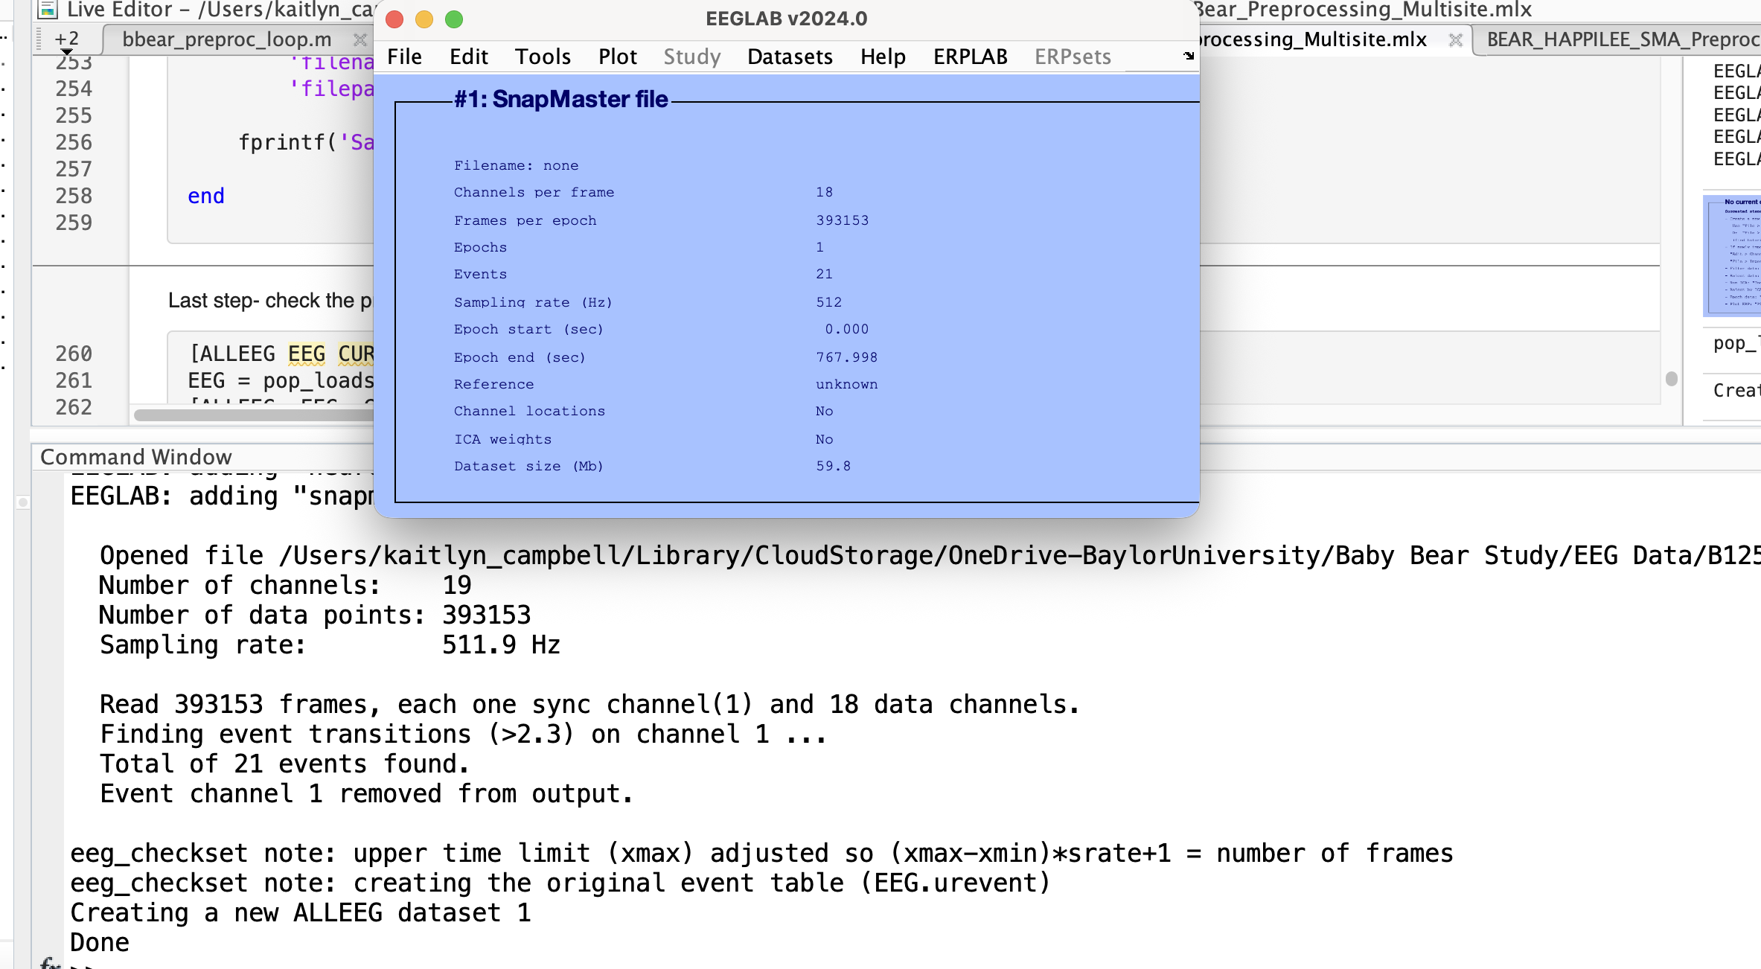
- Now we are going to import the channel locations
- Click Edit > Channel Locations then it’ll look like this
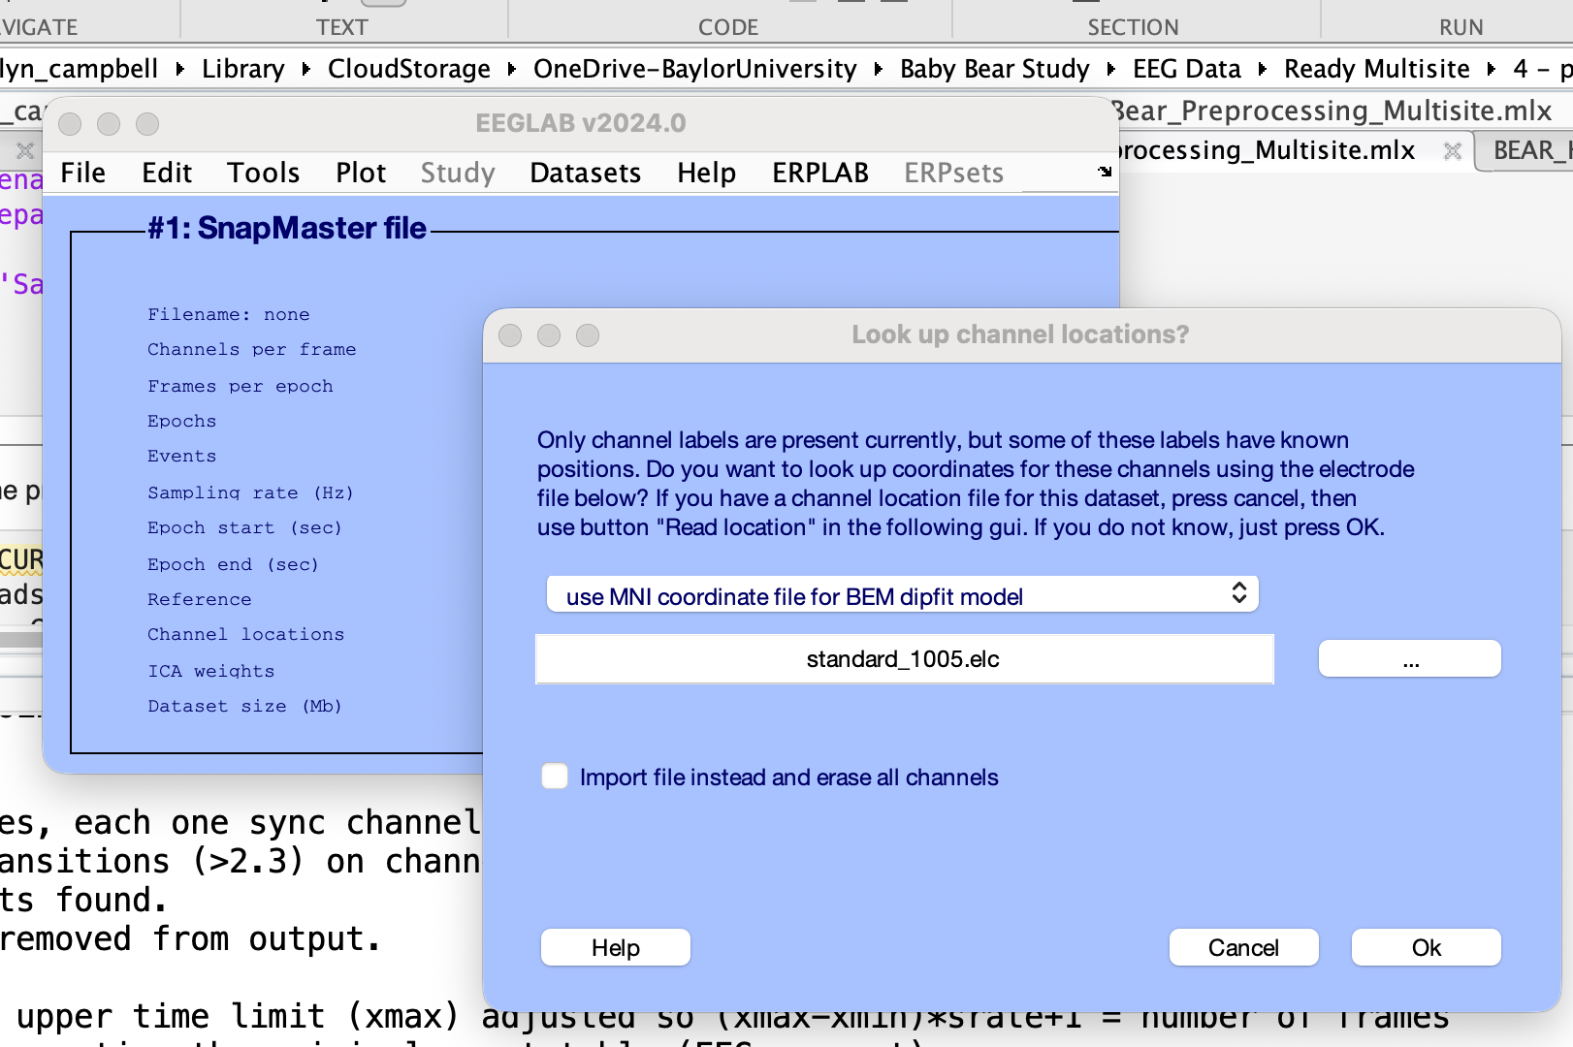
- Click Cancel on that “Look up channel locations?” window
- Then this window will come up
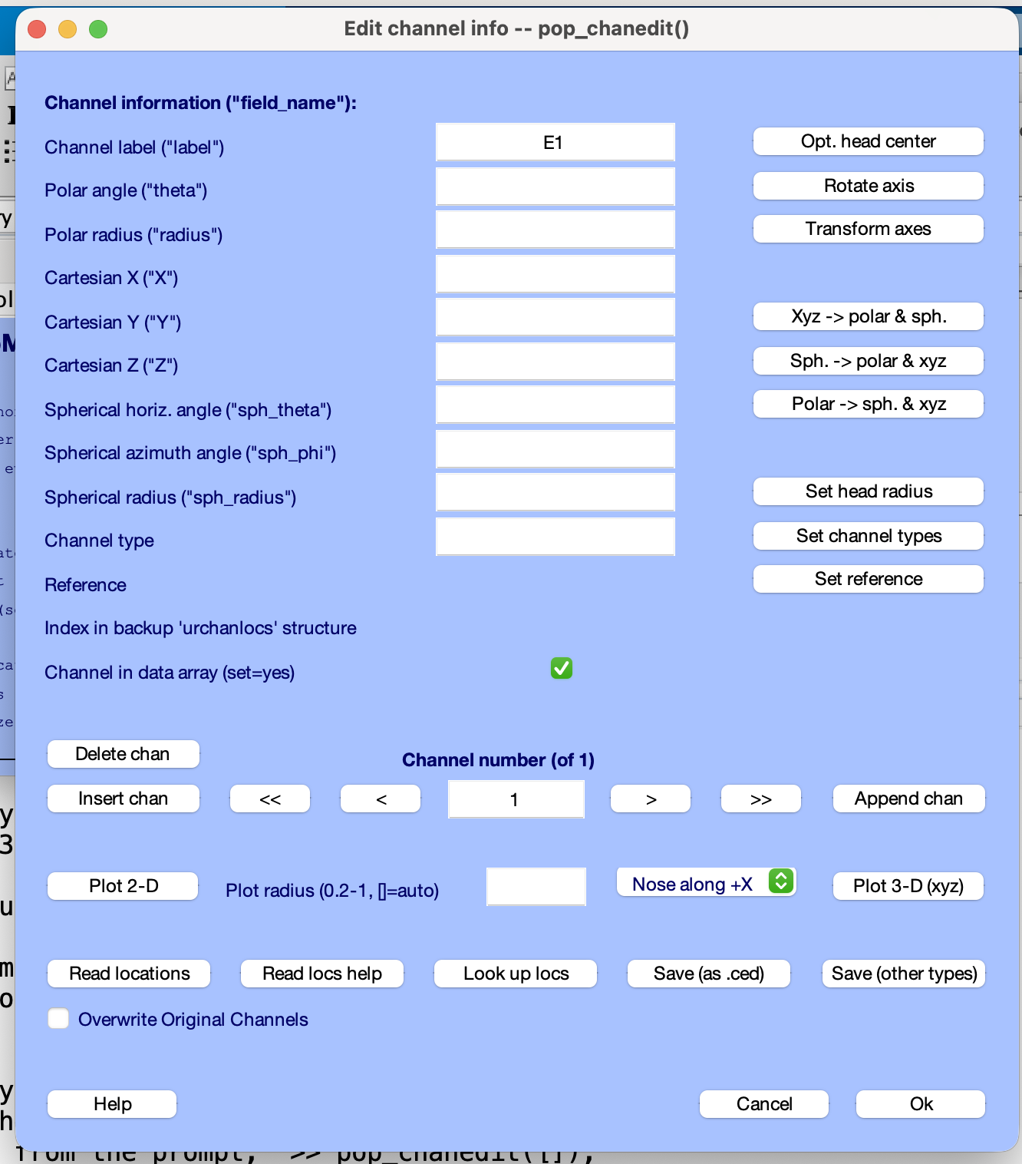
- Click Read locations then it’ll prompt you to choose a file from your computer (WSU = WSU_ChanLocs.locs; VT = VT_ChanLocs.locs; FAU = FAU_ChanLocs.locs)
- Then a new window will come up like this, it’ll choose autodetect, and click Ok
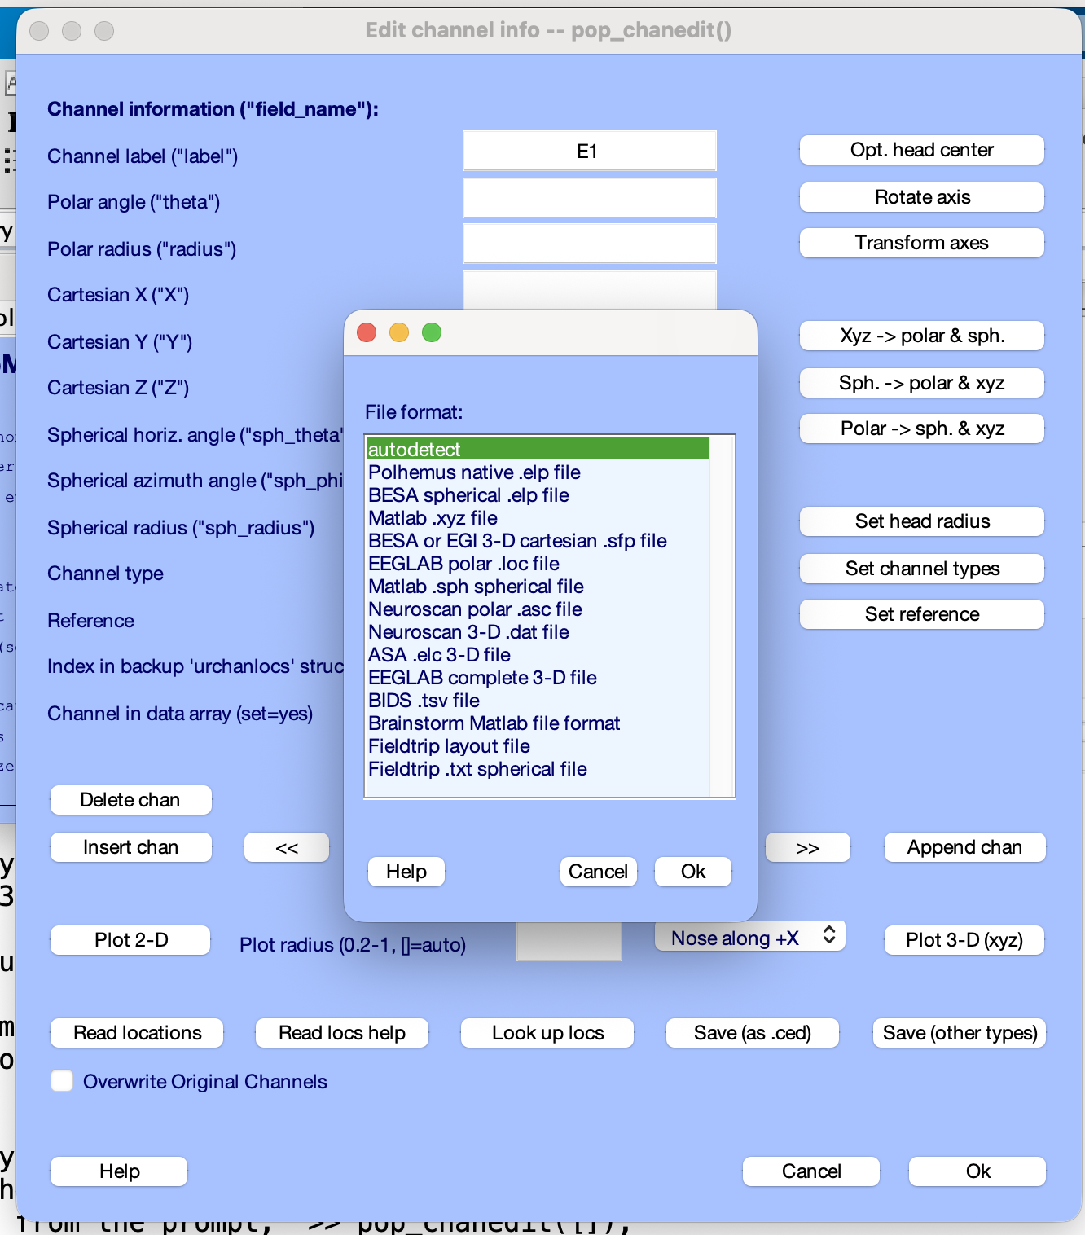
- Then click Ok on the “Edit channel info” window
- If the channel locations are wrong, then there will be another pop up right here saying there’s an issue. If so, screenshot the issue and scroll back on the command window and screenshot the text right when you import the .sma (like the image from step 5) and send to Kaitlyn (Kaitlyn_campbell@baylor.edu)
- If no error---Yay! Let move on to checking the relative gains.
- On the main GUI, click Plot then Channel data (scroll)
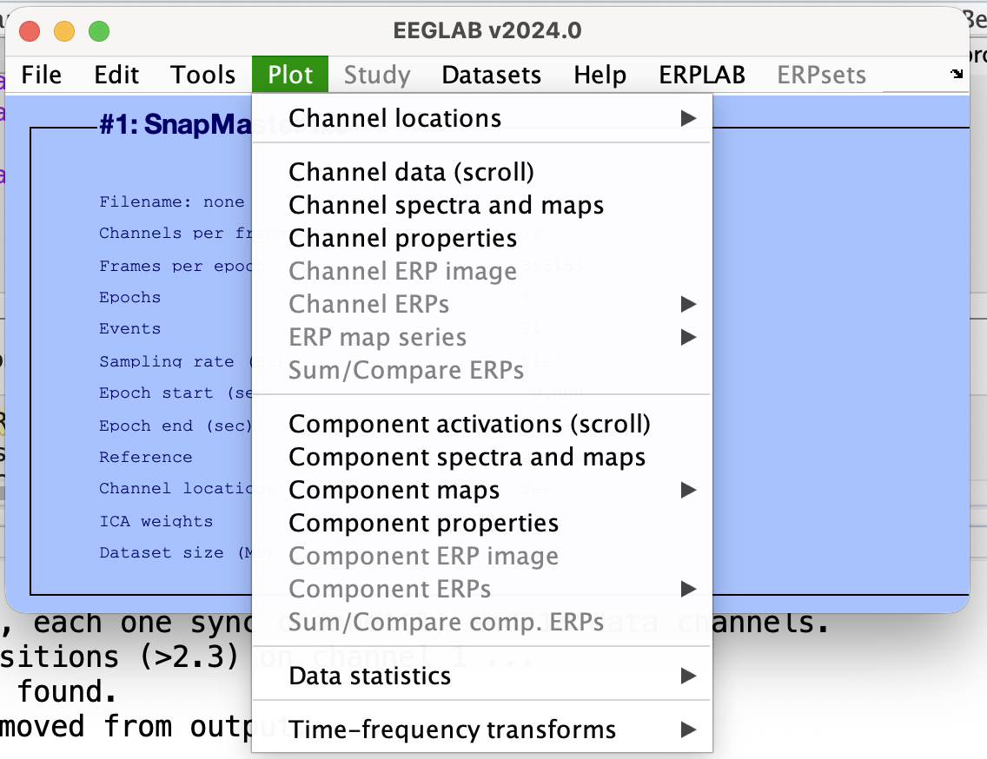
- A window of your EEG data will pop up. Make it full screen
- Click Display > Remove DC offset
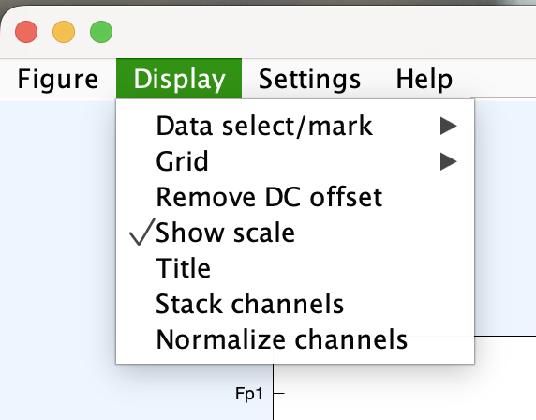
- Click Settings > Time Range to Display, in the pop up change to 10, hit okay
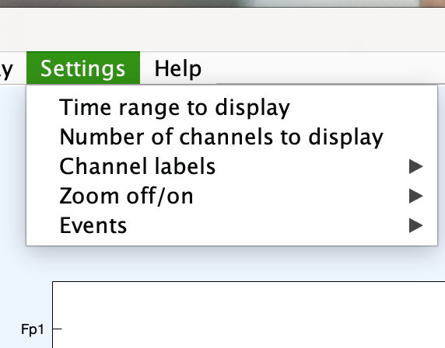
- Now to change the zoom, double click this box, change to 100, then click out of the box
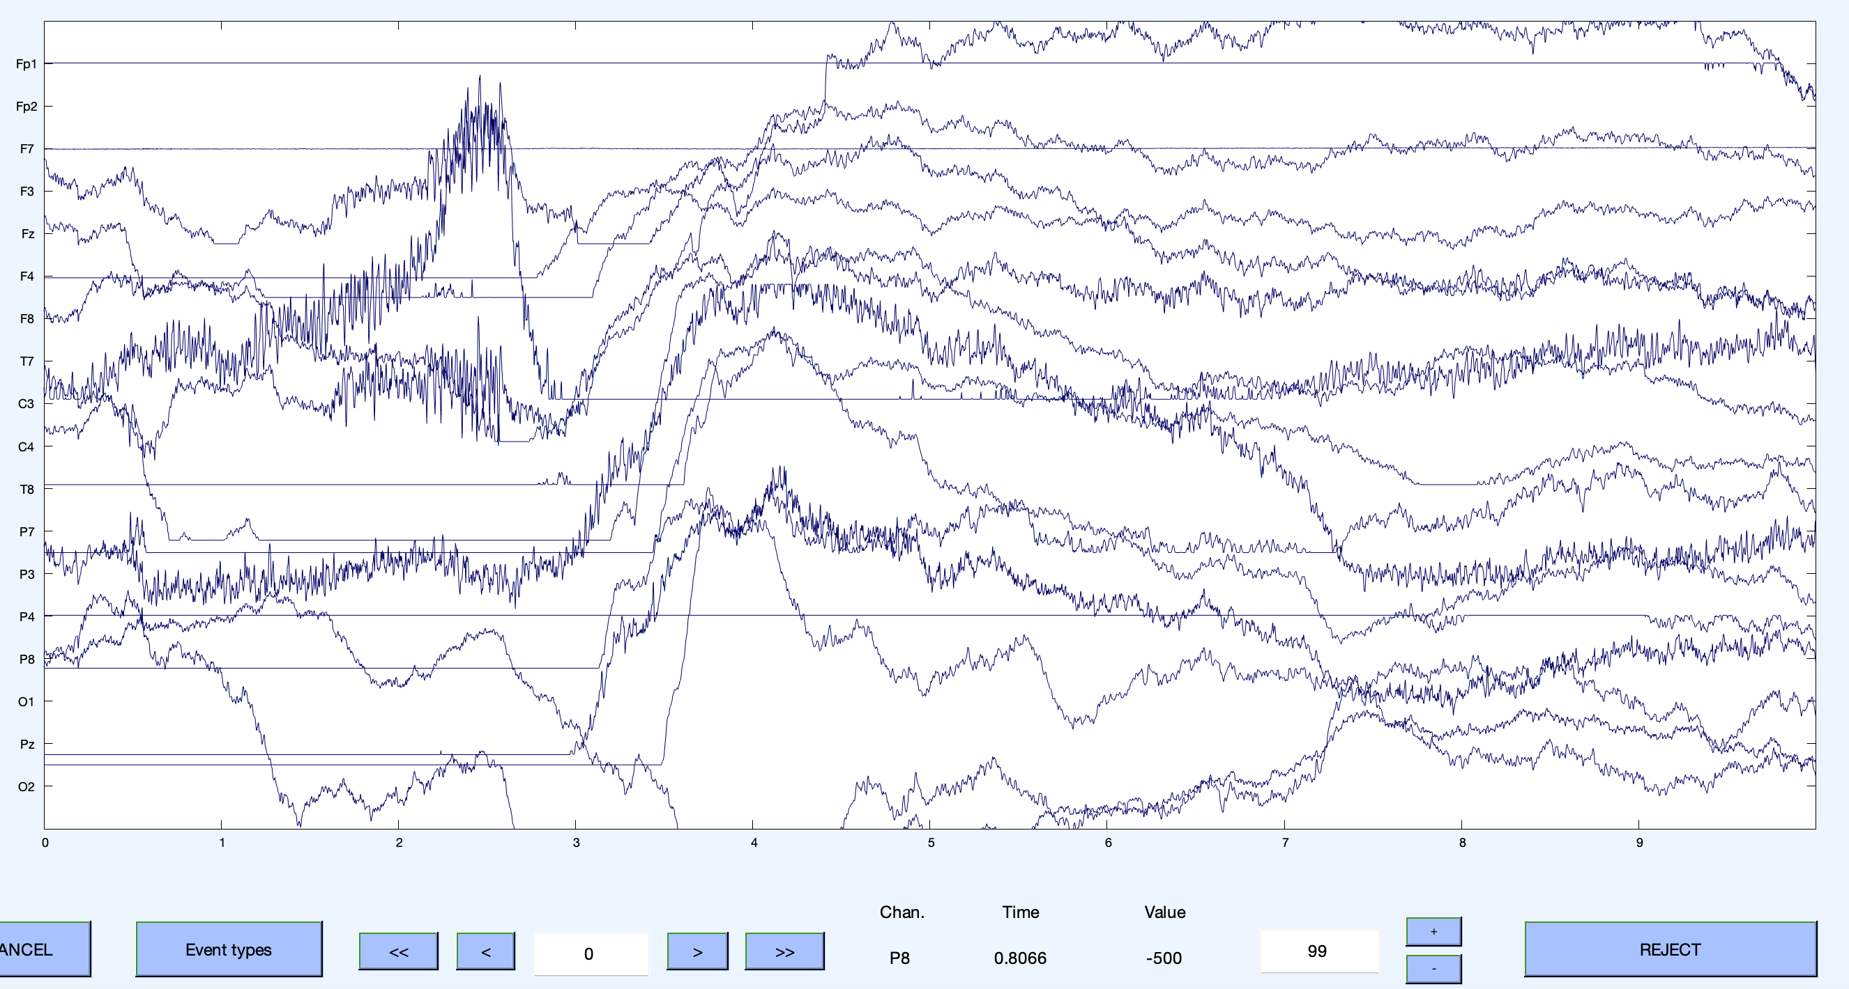
- Now the data is set up for manual inspection. Scroll through to find some data that looks generally clean, like this. Some electrodes are a bit noisy but most seem good. While on the data, put your mouse on the data of a specific electrode then look at the bottom value. For the most part, the values should be between roughly ± 50
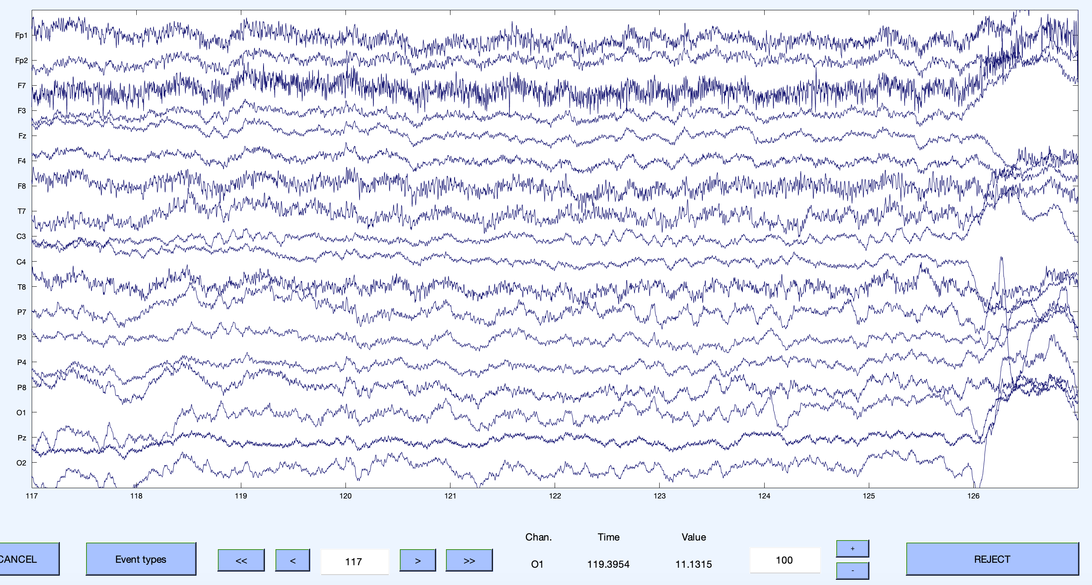
- If your values are very different, check another file. If you still have very different values, then email Kaitlyn to troubleshoot.
- Once both the channel locations and relative gains are settled, then you’re good to process all of your data.

Preprocessing Information & Instructions
Input: .sma & .cnd
Output: .txt event file, .set EEGLAB files per step
What the code does:
- Preprocesses the .cnd file into a .txt file
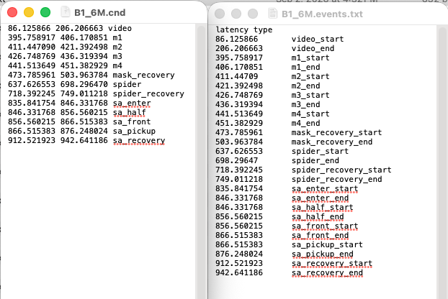

- Reads in the raw .sma data (be sure to set the relative gains to yours!)
- Saves the new .set file as ID.raw.set and saves in the individual Processed folder
- Sets the sampling rate to 512
- Reads in all channel locations except for Cz
  - Including whatever extra channels your site has (if any)
- Saves as ID.czref.set in the individual Processed folder
- Adds back in Cz manually and sets it as the reference
- Reads in the .txt event file we made earlier
- Selects only the electrodes for the multisite analyses (Fp1/2, F3/4, F7/8, C3/4, T7/8, P3/4, P7/8, O1/2)
- Saves as ID.events.set in the individual Processed folder
- Makes individual .set files per task
- Saves as ID_task.set in the individual Processed folder AND in the Ready folder for HAPPILEE
- Opens the data automatically, so you can inspect for missing tasks, broken electrodes, or anything weird.

How to set up to run the preprocessing code:
- Once per site: will need to change the main file paths in the code, relative gains (line 113), and site
- For every file: subjectID, and then command+f/control+f for the participant ID/age
- To process only channels used across sites: run Baby_Bear_Preprocessing_Multisite.mlx
- These files are called ‘live scripts,’ which are similar to an r markdown file in RStudio.
To run the code: after editing what you need to, click the green arrow
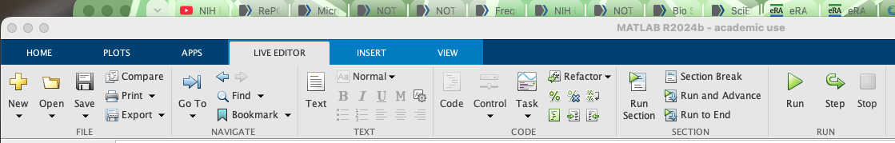

The code will run and populate information in the output area and at the end the channel data graph will pop up as well.

Do this for every EEG file you have. Anyone can be trained to help on this task. I recommend creating a log to keep track of preprocessing progress.

How to Run HAPPILEE
- Open your HAPPE-master folder
- Open 1. pre-process
- Open the HAPPE_v4.m file into Matlab
- Click Run in the Matlab editor (same green arrow as before)
- Look in the command window- this is where you will provide information and answer questions from the code.
  - You will enter your path, say it’s raw data, load in the parameter file (happilee_parameters.mat), look at the parameters, and then once you say N to changing a parameter, the code will run in a loop over all the files present in the folder.
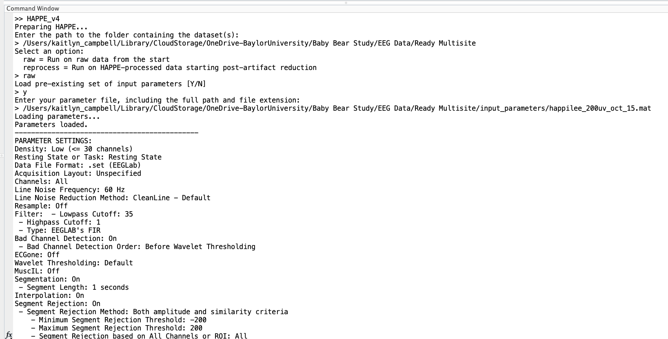
Here’s an example of all the questions:

  - Once it’s done running, the last line in the command window will be “Generating quality assessment outputs…” and you’ll know that you’re good to go. The run time varies a ton- depending on computer specifications and the amount of data. When I ran about 1500 files it look about an hour.
How to extract power estimates:
- Open your HAPPE-master folder
- Open 3. generate
- Open the generatePower.m file into Matlab
- Click Run in the Matlab editor (same green arrow as before)
- Look in the command window- this is where you will provide information and answer questions from the code.
  - You will enter your path (this time it’s the 4 – processed folder that the HAPPILEE code made), load in the parameter file (babybearstudy_power_params.mat), look at the parameters, and then once you say N to changing a parameter, the code will run in a loop over all the files present in the folder.

How to determine sample inclusion:
- Open the Inclusion excel template
- Go to your folder where you processed your data and open the 5 – quality_assessment_outputs folder
- Open the HAPPE_dataQC csv into excel. Here’s an example:
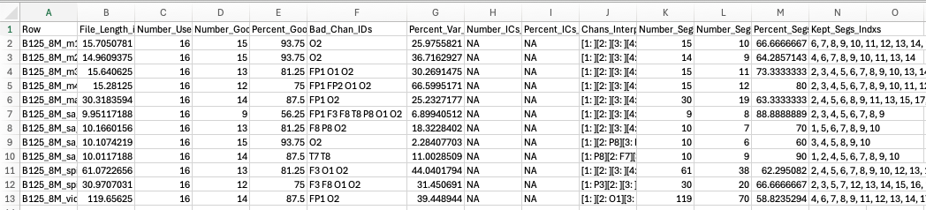
- Add columns after the Bad_Chan_IDs (enough to cover the largest number of bad electrodes)
- In the new column G on row 2, type =TEXTSPLIT(F2, “ “) and hit enter. Drag this formula down to copy for all rows. This will automatically split the list of bad channels by individual electrode
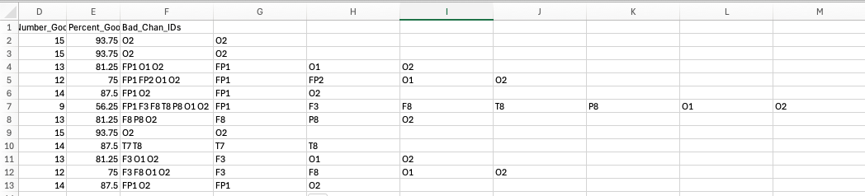
- Now add 5 more columns after your last electrode one. Name them P3, P4, F3, F4, More than 1 in ROI?
  - For the individual electrode columns, type =COUNTIF( then highlight the range of the individual bad channel columns then type , “P3”) so the function will be something like =COUNTIF(I2:P2, “P3”)
  - Copy this function down for all rows and across for the other P3/4, F3/4 columns. Then change the electrode for the respective column.
  - In the ‘More than 1 in ROI?’ column, type =IF(SUM( highlight the P3/4 & F3/4 columns then type )>=2, “Yes”, “No”)
- Copy everything onto the inclusion excel sheet
- Now go back to your files and open up the other quality assessment output called HAPPE_pipelineQC
  - Copy everything and paste it onto the inclusion excel sheet
- In the ‘Comments’ column, you can add information from the lab visit or any other comments.
- In the ‘Exclusion Reasons’ column, you will list any reasons for exclusion.
Main exclusion criteria:
- More than 1 bad channel in the ROI (F3/4, P3/4)
- <40% usable epochs
- < .2 r pre/post wavelet (30Hz)
- < .9 r pre/post linenoise (50, 55, 65, 70Hz)
- Other exclusion criteria could be a file that is overly long or something else reported from the lab visit
- I typically highlight the cell(s) red of the criteria not met. You can sort smallest/largest or set conditional rules for highlighting.
- Once you know what files need to be excluded, you need to make a list of them (a csv with ID and reason for exclusion is perfect). This file needs to be shared between sites to make sure we do not use power estimates from unusable EEG files.

